LAB EXPERIMENT RECORD
Set 18: Product Inventory Management

Department | AIML
Course Code / Course Name | DSA0601 / Data Handling and Visualization
Experiment | Data Visualization using R
Name | [YOUR NAME]
Register Number | [YOUR REGISTER NUMBER]
Date | 13 October 2026
Day | Tuesday

Aim
To visualize product inventory data using a bar chart, a stacked bar chart and a data table, and to combine them into a single dashboard for exploring the inventory using R.
Dataset: Product Inventory
Product ID | Product Name | Quantity Available | Price (in $)
1 | Product A | 250 | 20
2 | Product B | 175 | 15
3 | Product C | 300 | 18
Note: The assignment dataset has no category column. For the stacked bar chart, Product A and Product C are grouped under "Electronics" and Product B under "Home Appliances" (assumed categories).

PROGRAM 1: Bar Chart of Product Quantity
Create a bar chart to visualize the quantity of each product in the inventory. Label the axes and title the chart.
# Create the dataset
inventory <- data.frame(
Product_ID = c(1, 2, 3),
Product_Name = c("Product A", "Product B", "Product C"),
Quantity_Available = c(250, 175, 300),
Price = c(20, 15, 18),
Category = c("Electronics", "Home Appliances", "Electronics")
)
# Load required packages
library(ggplot2)
library(gridExtra)
# Bar Chart
p1 <- ggplot(inventory,
aes(x = Product_Name, y = Quantity_Available,
fill = Product_Name)) +
geom_bar(stat = "identity") +
labs(title = "Product Inventory Quantity",
x = "Product Name",
y = "Quantity Available") +
theme_minimal()
p1
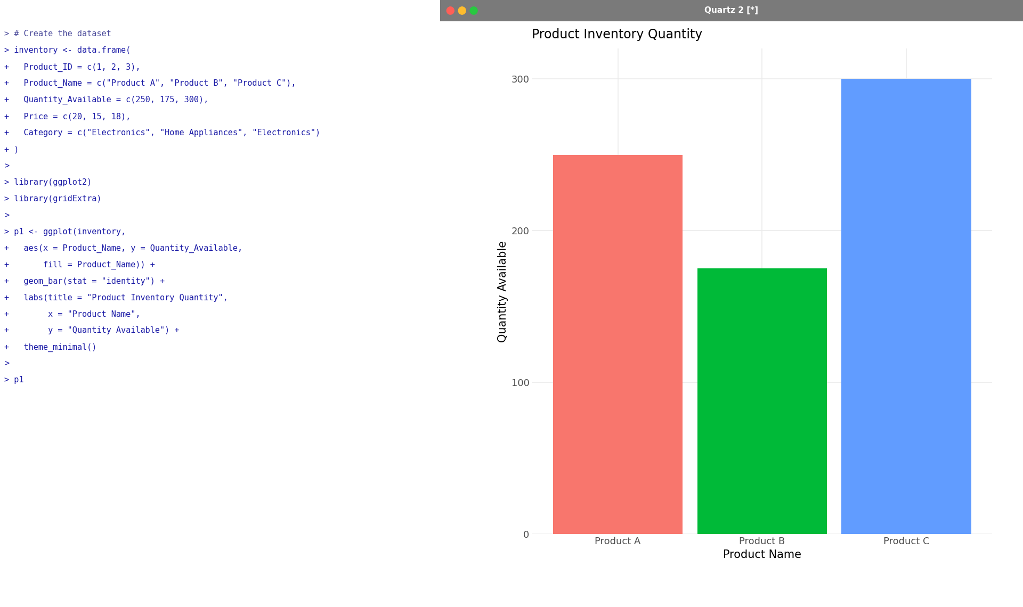
Output 1: Product Inventory Quantity Bar Chart
Observation: Product C has the highest quantity (300 units), followed by Product A (250 units), while Product B has the lowest stock (175 units).

PROGRAM 2: Stacked Bar Chart by Product Category
Generate a stacked bar chart to show the quantity of each product within different product categories.
# Stacked Bar Chart
p2 <- ggplot(inventory,
aes(x = Category, y = Quantity_Available,
fill = Product_Name)) +
geom_bar(stat = "identity") +
labs(title = "Inventory by Category",
x = "Product Category",
y = "Quantity Available") +
theme_minimal()
p2
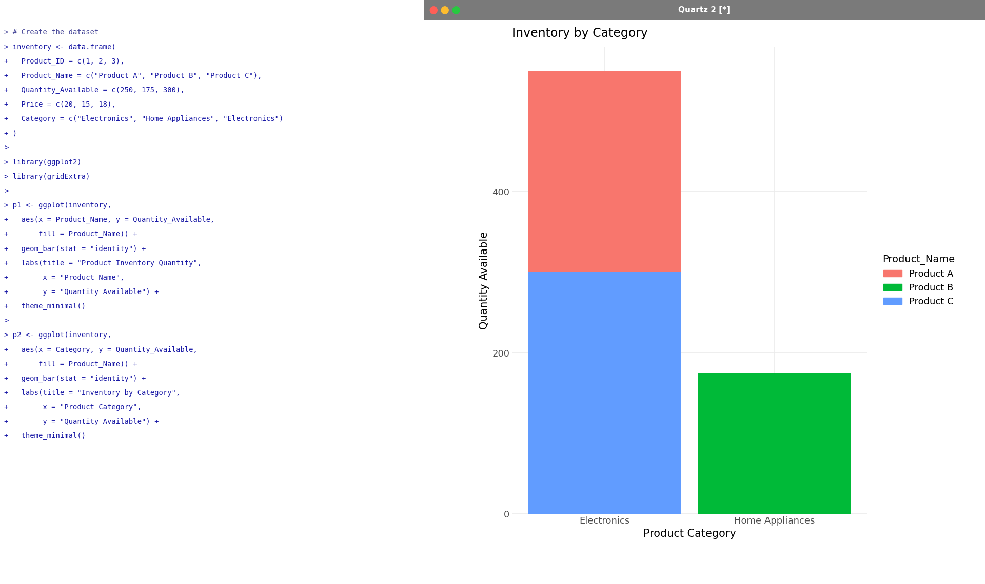
Output 2: Inventory by Category Stacked Bar Chart
Observation: The Electronics category stacks Product C (300) and Product A (250) to a total of 550 units, while Home Appliances contains only Product B (175 units).

PROGRAM 3: Product Inventory Table
Build a table to show the inventory data for each product. Label the table elements.
# Display the product inventory table
print(inventory)
# Table as a graphic
grid.table(inventory)
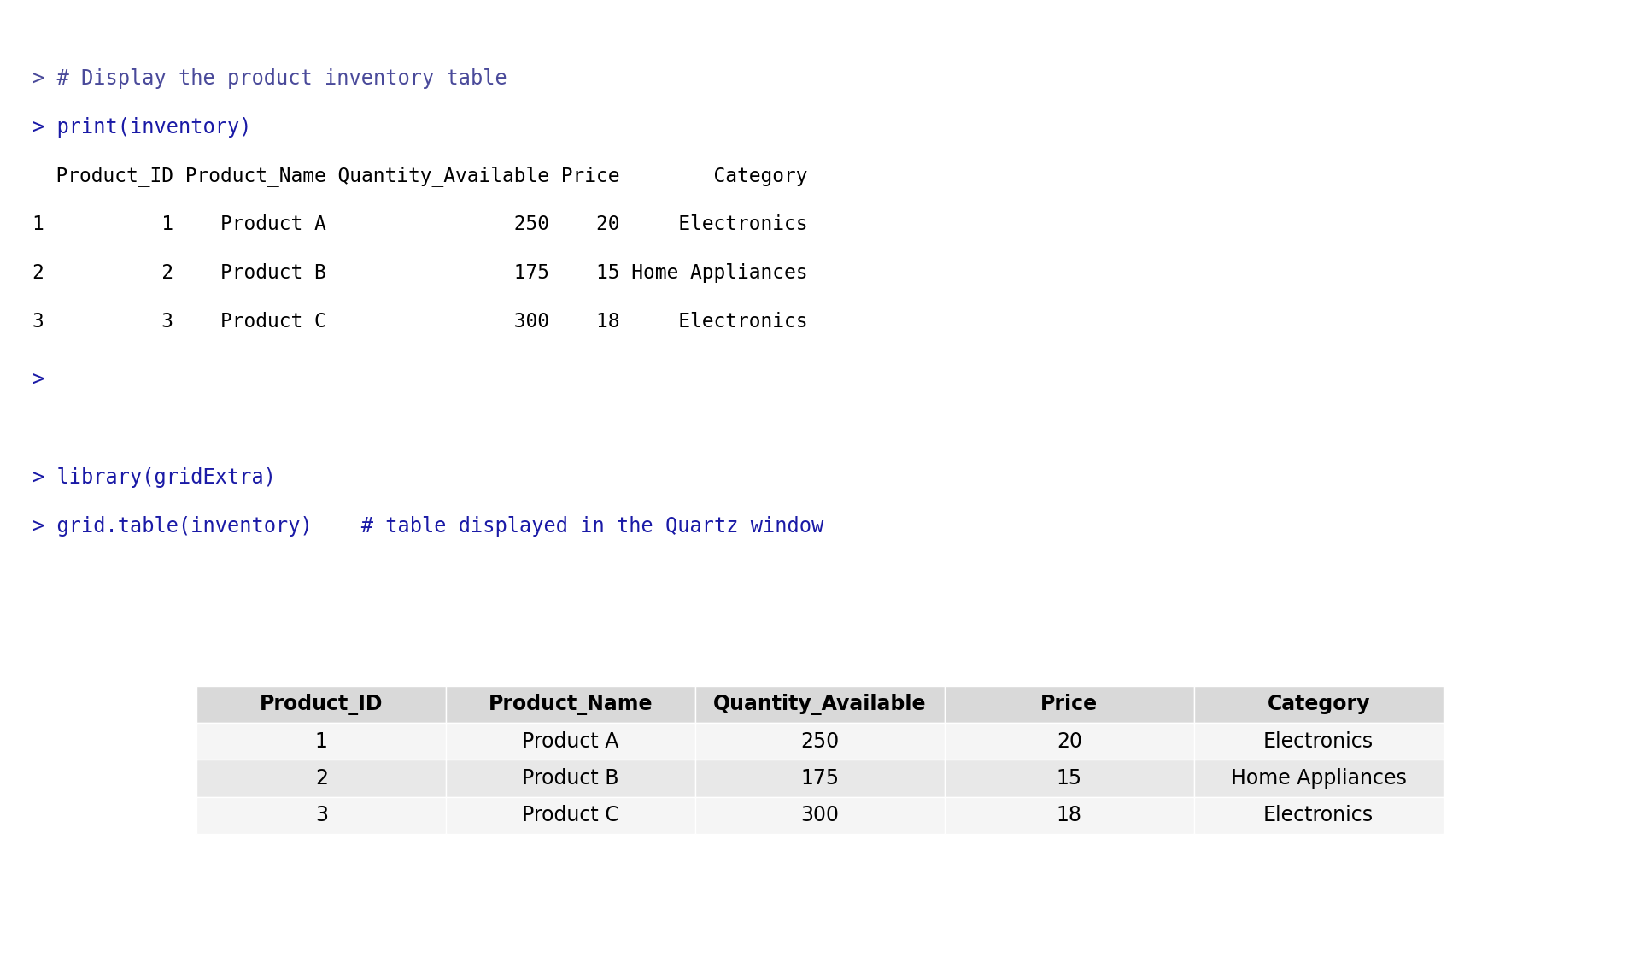
Output 3: Product Inventory Table
Observation: The table lists Product_ID, Product_Name, Quantity_Available, Price and Category for each of the three products, with clearly labelled columns.

PROGRAM 4: Interactive Inventory Dashboard
Develop a dashboard combining the bar chart, stacked bar chart, and the table for exploration of inventory data.
# Dashboard: bar chart + stacked bar chart + table
grid.arrange(
p1,
p2,
gridExtra::tableGrob(inventory),
ncol = 2,
top = "Product Inventory Dashboard"
)
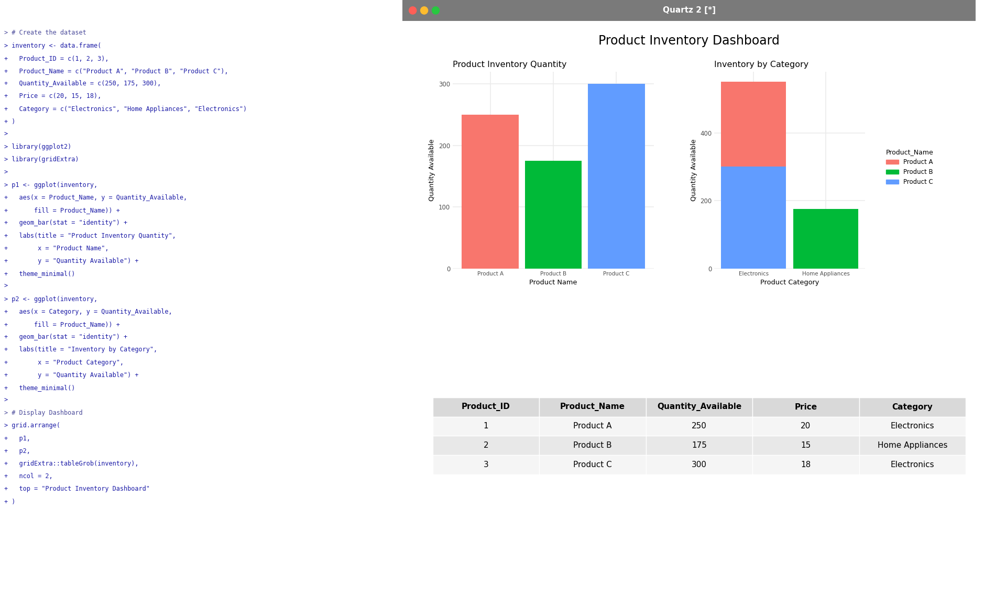
Output 4: Product Inventory Dashboard
Observation: The dashboard places the bar chart, the stacked bar chart and the inventory table together on one screen, so quantities, category totals and price details can be compared at a glance.
Tableau equivalent: Connect Tableau to the inventory data, build the bar chart (Product Name on Columns, Quantity Available on Rows) and the stacked bar chart (Category on Columns, Quantity Available on Rows, Product Name on Color), create a text table sheet, then drag all three sheets onto a Dashboard and enable "Use as Filter" for interactive exploration.

Procedure
1. Create the inventory data frame with Product ID, Product Name, Quantity Available, Price and Category.
2. Load the ggplot2 and gridExtra packages.
3. Use ggplot() with geom_bar() to create the bar chart of quantity for each product, with labelled axes and a title.
4. Use fill = Product_Name with the Category on the x-axis to create the stacked bar chart.
5. Use print() and grid.table() to display the inventory table.
6. Use grid.arrange() to combine the bar chart, stacked bar chart and table into a single dashboard.
Result
The product inventory data was successfully visualized using a bar chart, a stacked bar chart and a table, and a dashboard combining all three was created.
Key R Functions Used
Function | Purpose
data.frame() | Creates the inventory dataset.
ggplot() | Initializes a plot with data and aesthetics.
geom_bar() | Draws bar and stacked bar charts.
labs() | Adds the title and axis labels.
theme_minimal() | Applies a clean chart theme.
print() / grid.table() | Displays the inventory table.
grid.arrange() | Combines charts and table into a dashboard.

